Modeling with UML

- Model an ATM
Draw a use case diagram for an ATM (cash terminal). The system includes two actors: a customer, who draws money from his account either on the money chip on his bank card or in cash, and a security man, who fills money into the ATM.
Use cases should include: DrawCash, LoadMoneyChip, CheckAccountBallance, FillATM. Also include the following exceptional cases: OutOfMoney, TransactionAborted (i.e., customer selected the cancel button without completing the transaction) and MoneyChipOutOfOrder.
Remark: It is possible to use inheritance between use cases!

Write the flow of events and specify all fields for the use case CheckAccountBalance that you drew before. Specify relationships.

Solution:

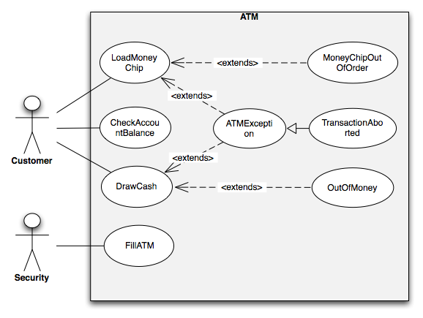

Use case name | CheckAccountBalance
Participating Actors | Initiated by Customer
Flow of events | 1. The Customer inserts his bank card into the ATM.
 |  | 2. The ATM welcomes the Customer and opens the main menu.
 |  | 3. The ATM waits for the selection from the Customer.
 | 4. The Customer selects the “CheckAccountBalance” function by pressing the appropriate button.
 |  | 5. The ATM system shows the enter PIN screen to the Customer.
 | 7. The Customer enters his correct PIN and confirms it.
 |  | 5. The ATM system shows the actual balance of the Customer’s account.
Entry condition | The ATM is working and Customer is in front of the terminal.
Exit condition | The Customer can view his account balance.
Quality requirements | The ATM stays online for the whole period of the CheckAccountBalance use case.
Figure 1

- Model a book
Draw a class diagram representing a book defined by the following statement: “A book is composed of a number of parts, which in turn are composed of a number of chapters. Chapters are composed of sections.” First, focus only on classes and associations.

Add multiplicity to the class diagram you produced.

Refine the class diagram to include the following attributes:
- Book includes a publisher, publication date, and an ISBN
- Part includes a title and a number
- Chapter includes a title, a number, and an abstract
- Section includes a title and a number

Consider the refined class diagram. Note that the Part, Chapter, and Section classes all include a title and a number attribute. Use inheritance to factor out these two attributes .

Solution:

1.)

2.)

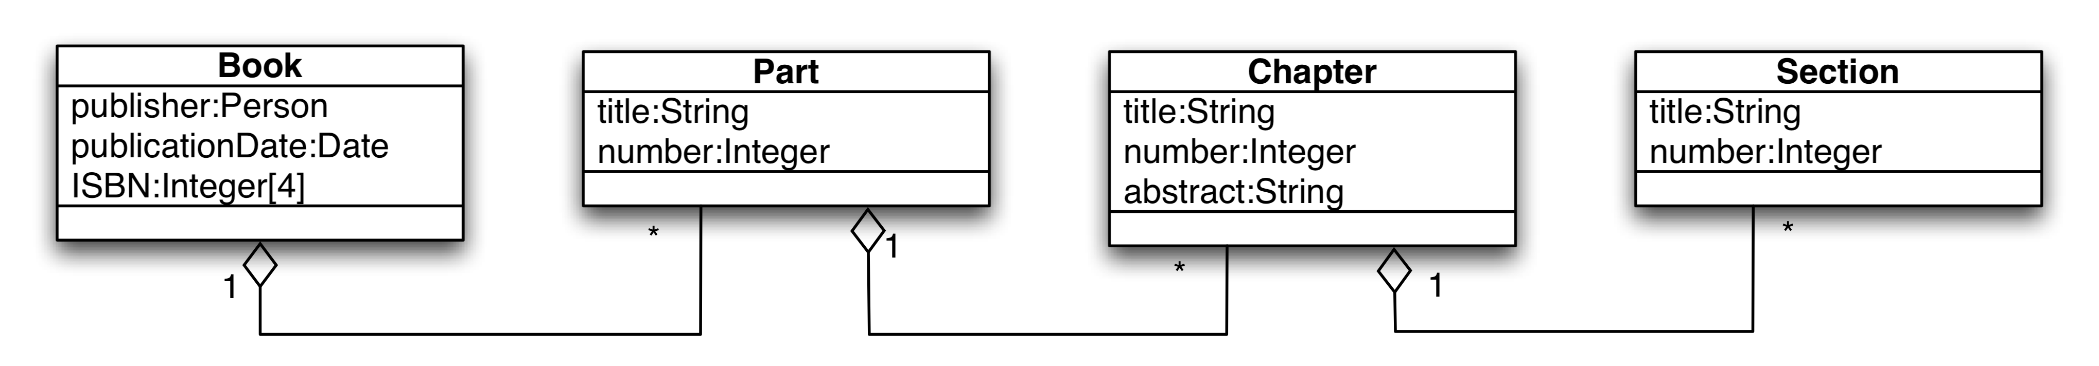

3.)

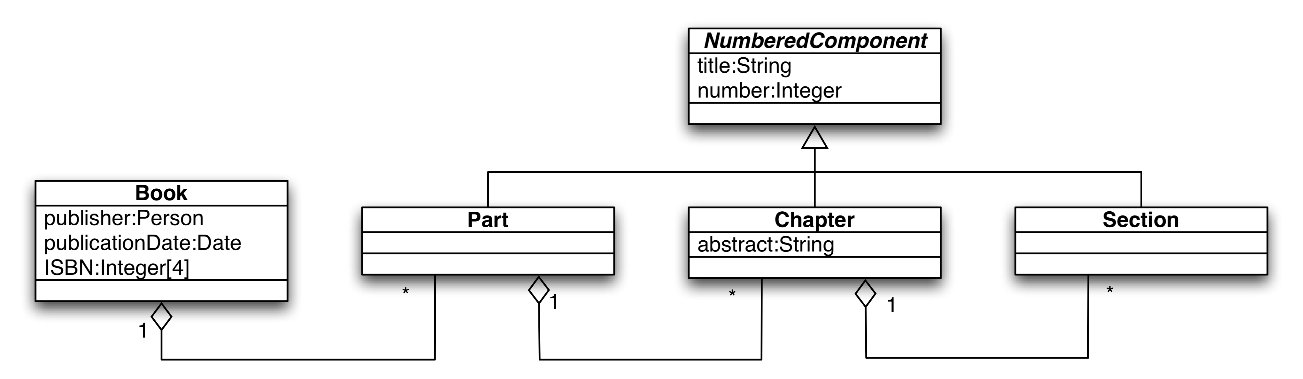

- Happy Hour Message
Draw a sequence diagram for the HappyHourMessage scenario in the figure below. Draw only the first five messages exchanged.

Solution:

Scenario name | HappyHourMessage
Participating actor instances | bob, alice: BarFlies  john: Friend
Flow of events | - Bob and Alice are sitting in their favorite pub and it’s happy hour.  They want to invite their common friend John who likes cocktails and didn’t know about the newly scheduled happy hour. Alice takes out her “mobile phone” and activates the “SMS” function.  - Alice enters John’s cell phone number and writes the message about the happy hour into the “SMS text field”. She sends the message and waits for John’s answer.  - John, who is still at work, is alerted by a sound of his cell phone that a new “SMS” has arrived. He reads the lines from Alice and answers that he will come immediately. He quits working and leaves the office.  - Alice receives John’s answer at her “mobile phone”.
Figure 2
Solution:
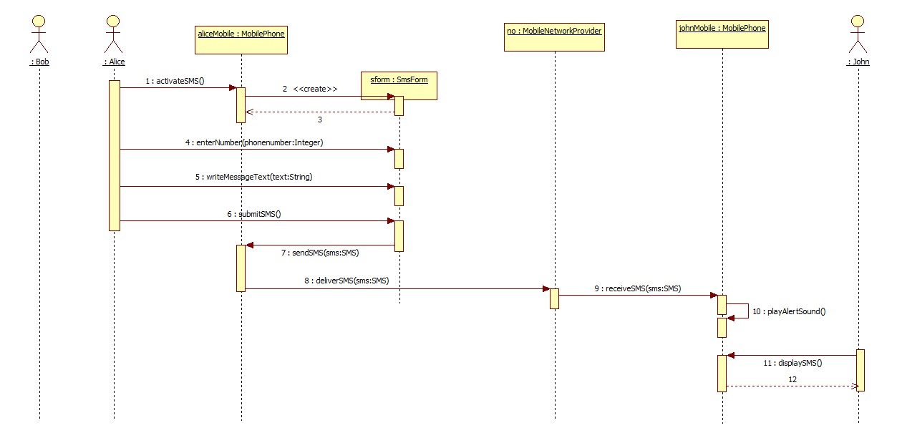

- Model an online bookstore
Consider the process of ordering a book via Internet. Draw an activity diagram representing each step of the process, from the moment you open the shop’s web page to the point when you start reading the book, including login or registration. Include activities that others need to perform.

Add additional exception handling to the activity diagram you have developed. Model the following three exceptions:

- The order got lost in the Internet
- The wrong book is packaged
- The ordered book is no longer available

Solution:

